Unit Repossession – Closure and Valuation

- Purpose

When the customer still fails to settle his account after the motorcycle has been deposited for safekeeping, the Receptionist will now encode Closure and Valuation in preparation for unit repossession.

- Views
  - List View
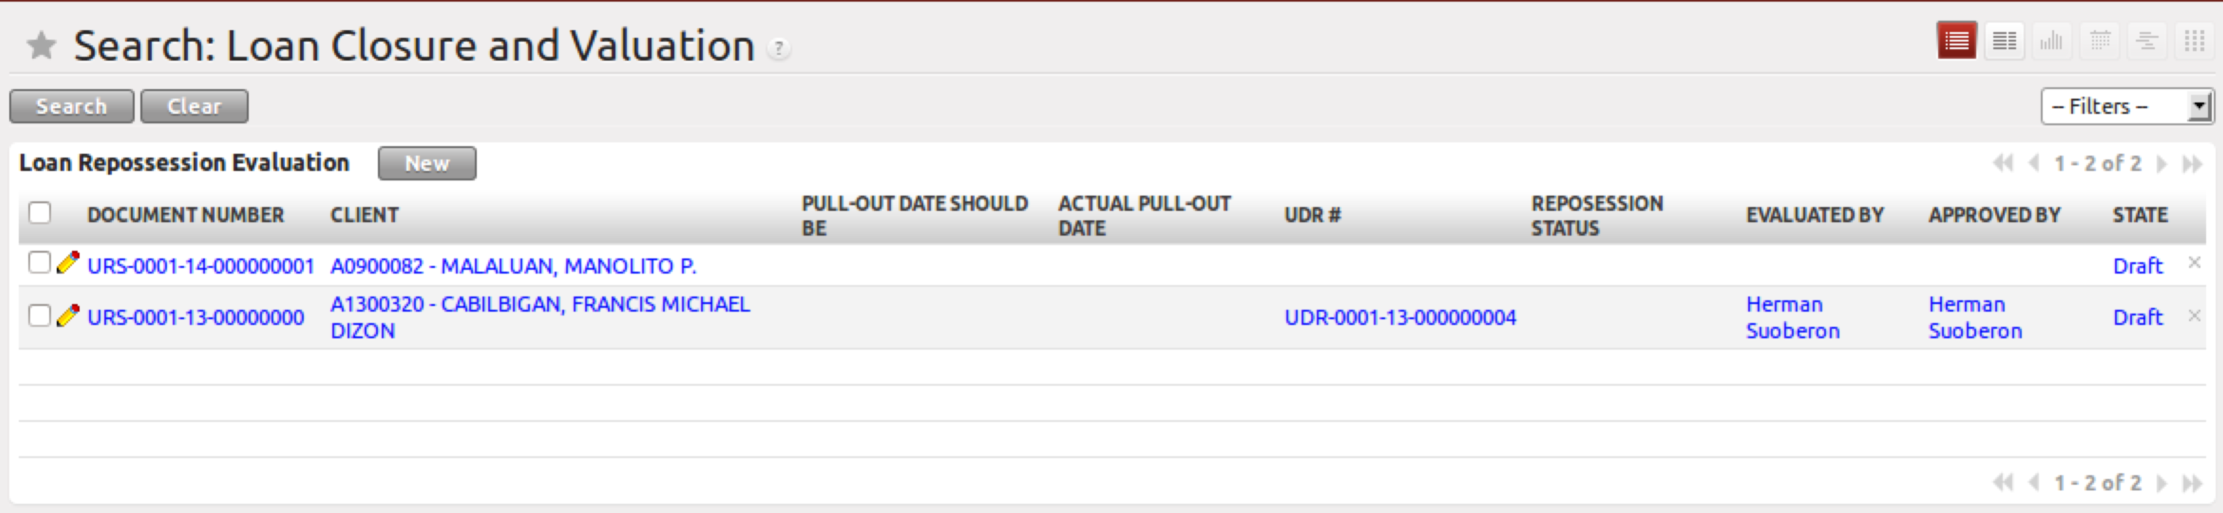
Figure 1. List view of Closure and Valuation

  - Form View
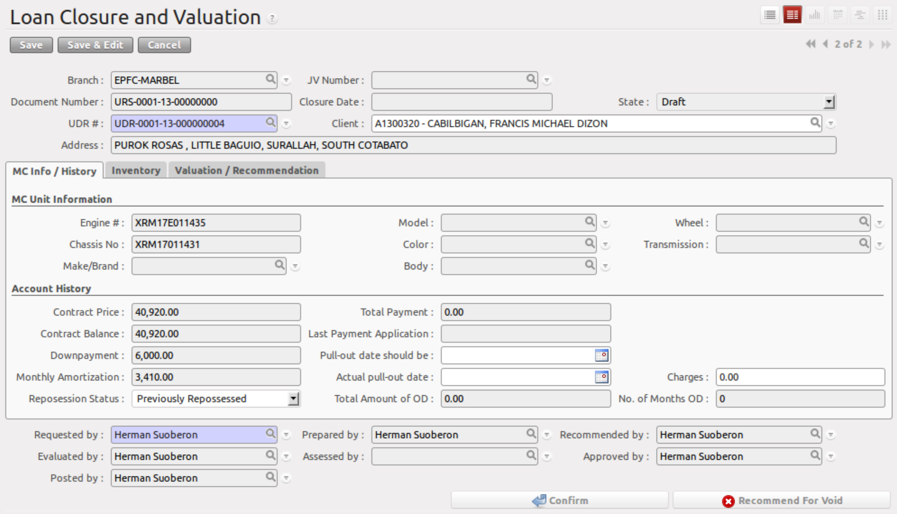
Figure 2. Form view of Closure and Valuation

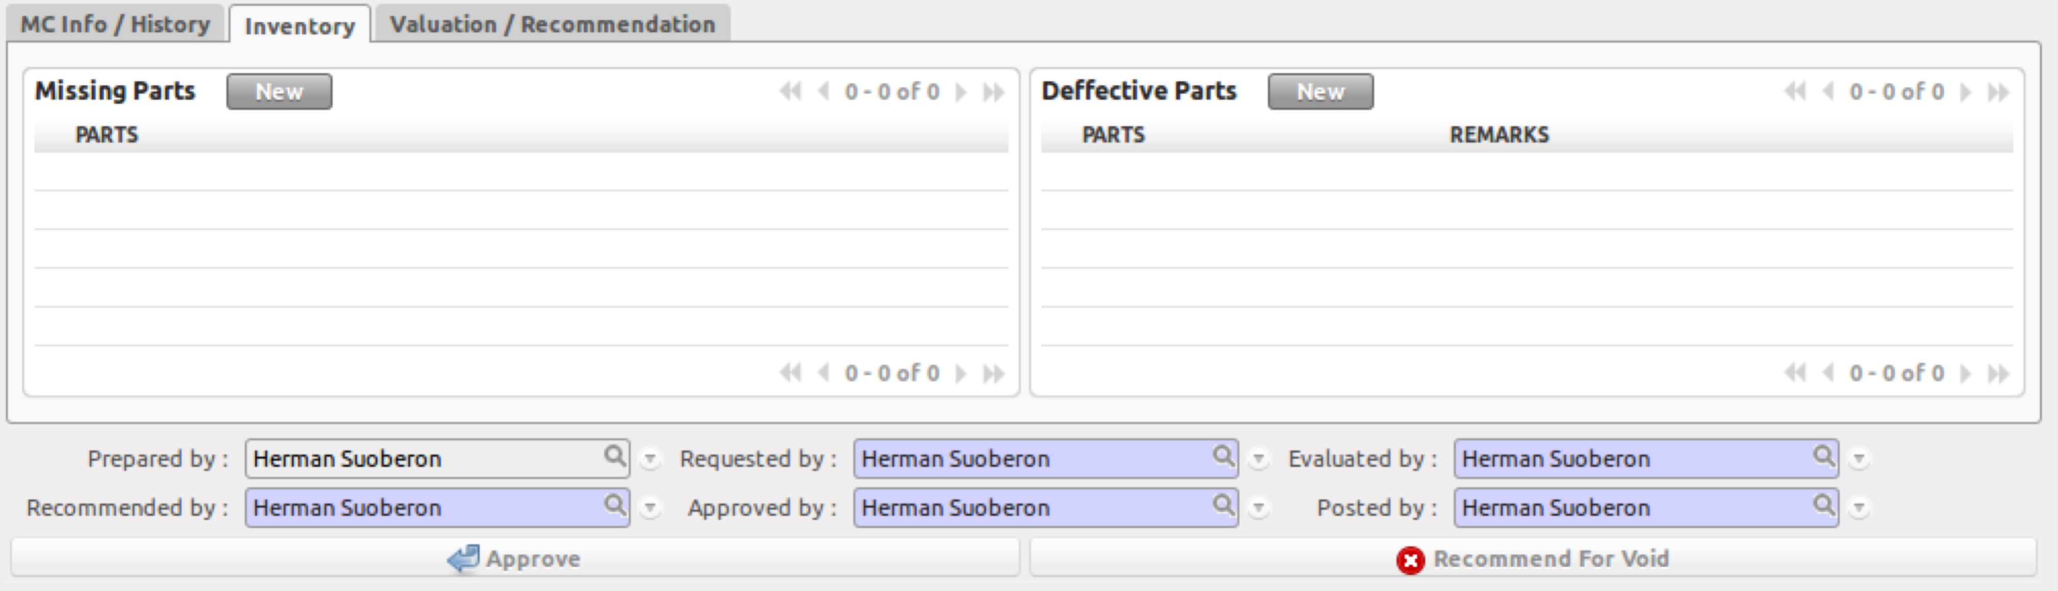
Figure 3. Inventory tab of Closure and Valuation

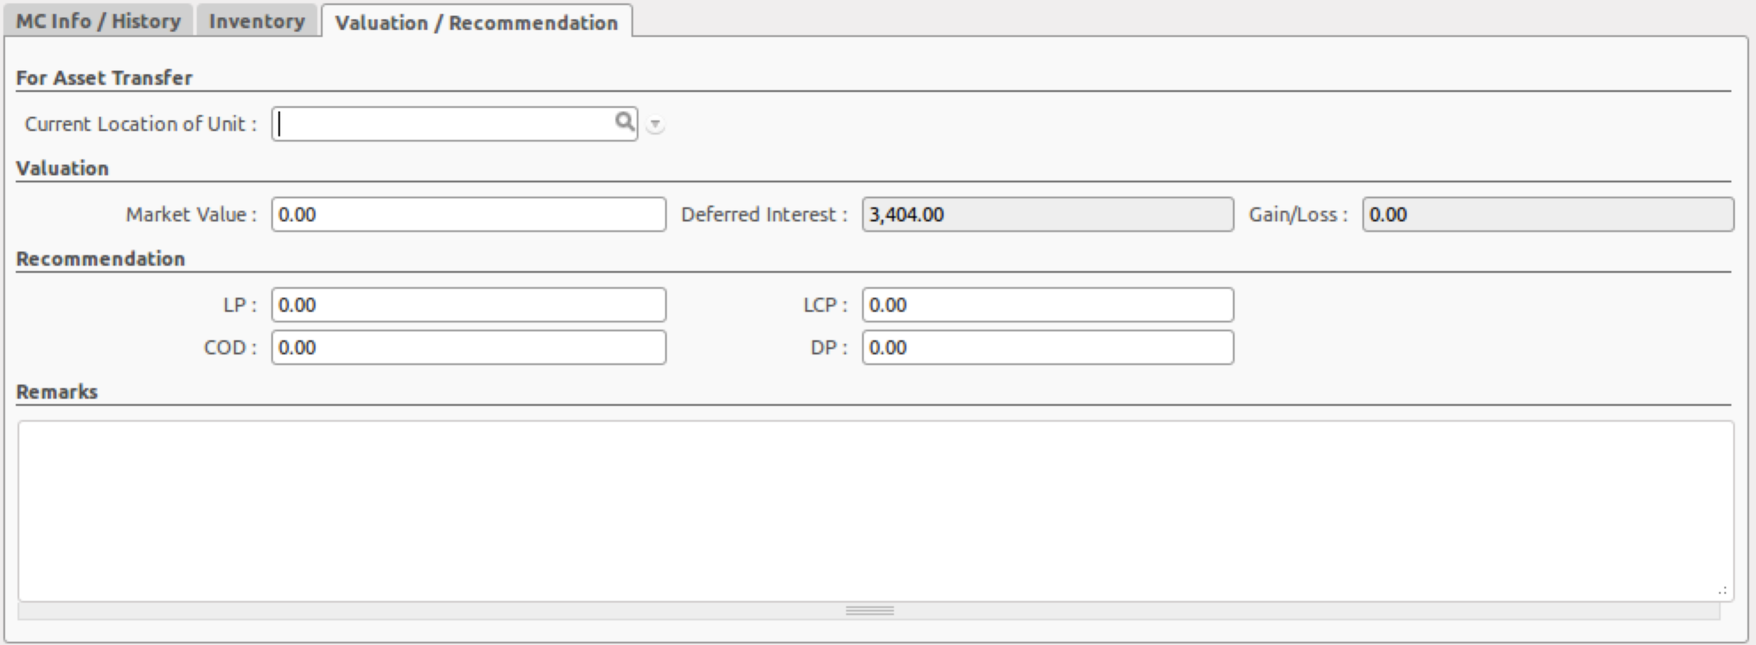
Figure 4. Valuation / Recommendation tab of Closure and Valuation

- Menu and Access Rights
  - Menu – Loan > Unit Repossession > Closure and Valuation
  - Access Rights
Role | Read | Write | Create | Delete
Receptionist | Yes | Yes | Yes | No
Cashier | Yes | No | No | No
CI/Collector | Yes | No | No | No
Branch Manager | Yes | No | No | No
Accounting Assistant (Branch) | Yes | Yes | Yes | No
Accounting Assistance 2 (Main) | Yes | Yes | No | No

- Required Fields
All required fields can be easily distinguished from the form view. These are the fields highlighted in Figure 2.

- Requested By – CI/Collector
- Prepared By – Branch Accounting Assistant/Receptionist
- Reviewed By – Branch Manager
- Evaluated By – MAA
- Assessed By – Assessor (Ramon Pulido)
- Approved By – General Manager
- Posted By – Main Accounting Assistant
- Market Value – price of the repossesed unit

- Workflow
Below is the list of states and visibility of the various buttons based on the record state:
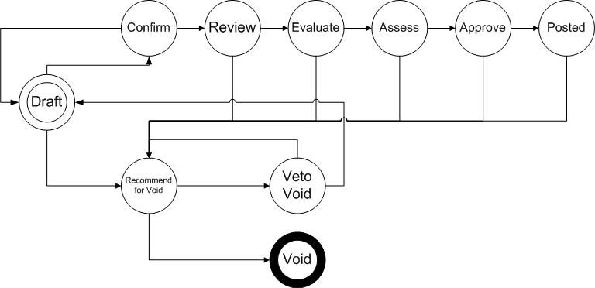
Figure 5. Workflow of Closure and Valuation

State | Description | Visible Buttons
Draft | Initial state of the record | Approve  Recommend for Void
Confirmed | Record has been submitted for review and no further changes is expected. | Reviewed  Recommend for Void
Reviewed | Record has been reviewed by the Branch manager | Evaluated  Recommend for Void
Evaluated | Record has been evaluated by the Main Accounting Assistant | Evaluated  Recommend for Void
Assessed | Record has been assessed by the Assessor and Market Value has been provided | Evaluated  Recommend for Void
Approved | Record has been approved | N/A
Posted | Journal Entries have been posted | Recommend for Void
Recommend for Void | Record was recommended for void by the accounting assistant | Veto Void Recommendation  Void  Approve
Void |  | N/A
Veto Void Recommendation | Cancels Recommendation for Void | Approve  Recommend for Void

- User Action
Below is the list of user action available for specific users and its corresponding procedures:

Button | Action | Triggred By
Confirm | No Action | Receptionist  Branch Accounting Assistant
Recommend | No Action | Branch Manager
Evaluate | No Action | Main Accounting Assistance
Assess | No Action | Assessor
Approve | - Creates product information found in Warehouse > MC Units > Repo Units  - Creates a draft record in Asset Transfer Slip  - Creates a draft journal entries | General Manager
Recommend for Void | No Action | Branch Accounting Assistant
Void | - Deletes product information found in Warehouse > MC Units > Deposited Units  - Voids the draft record in Asset Transfer Slip  - Voids draft journal entries | Branch Manager  Main Accounting Assistant
Veto Void Recommendation | No Action | Branch Accounting Assistant

- Field Visibility
All fields are visible to all users with read access to the record.

- Reports and Print Outs
